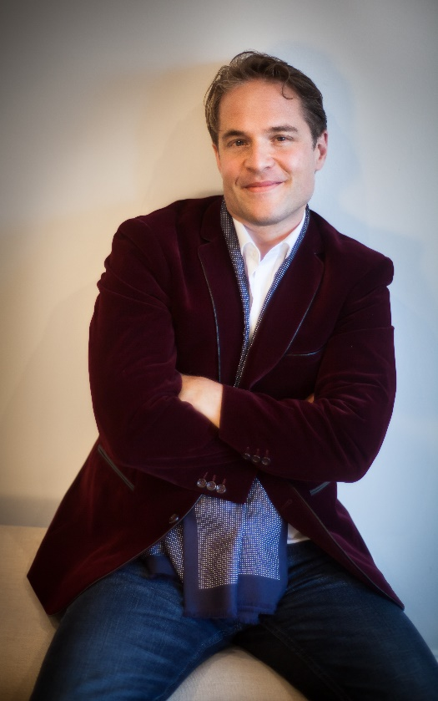
Lawrence Zazzo countertenor

The American countertenor Lawrence Zazzo is one of the most outstanding singers of his generation. A native of Philadelphia and a graduate in both English and Music from Yale University and King’s College, Cambridge, Lawrence made his operatic debut as Oberon A Midsummer Night’s Dream to great acclaim while completing his vocal studies at the Royal College of Music, London.
He has since appeared in many of the world’s finest opera houses and concert halls. His opera roles include the title role in Giulio Cesare (Metropolitan Opera New York, Paris, London, Amsterdam, Brussels, Seville, Bilbao), the title role in Gluck’s Orfeo (Vienna, Toronto, Oslo, Netherlands), Oberon A Midsummer Night’s Dream (Rome, Lyon, Aix-en-Provence, Toronto, Beijing, Hamburg, Palermo), Farnace Mitridate (Munich), the title role in Radamisto (English National Opera), Arsamene Serse (Theatre des Champs-Elysees, English National Opera, Oper Frankfurt), Bertarido and Unulfo Rodelinda (Opera de Lyon/Teatro Real Madrid), Goffredo Rinaldo (Berlin Staatsoper, Zurich, Opéra de Montpellier), Ottone Agrippina (Brussels, Frankfurt, Theatre des Champs-Elysees), Endimione La Calisto (Munich, Covent Garden, La Monnaie, Paris), Ottone L’incoronazione di Poppea (Vienna, Berlin, Brussels, Munich), Ruggiero in Orlando Furioso (Frankfurt), and the title roles in Handel’s Sosarme (Sao Carlo, Lisbon) and Alessandro (Karlsruhe).

Lawrence is also a keen advocate of 20th century and contemporary music. He created the role of Trinculo in Thomas Ades’ The Tempest at the Royal Opera House Covent Garden, as well as premiering Rolf Riehm's Sirenengesang (Frankfurt) and Die Tode des Orpheus (Saabrucken). His Paris Opera debut was as Kreon in Liebermann’s Medea, he has also sung Sciarrino’s Luci mie traditrici in Brussels, New York, and Rouen, as well as the role of Mascha in Peter Eötvos’ Three Sisters which he has performed in several productions in Lyon, Brussels, Edinburgh, Vienna, and the Netherlands. Lawrence made his BBC Symphony Orchestra debut in their commission of Jonathan Dove’s Hojoki (recently recorded for Orchid Classics) and sang the Refugee in Jonathan Dove’s Flight for the Glyndebourne Festival. He made his Wigmore recital debut with a programme of 20th-century American songs, having also premiered there a commissioned song cycle of Shakespeare fool songs by composer Iain Bell.

Lawrence has worked with many distinguished conductors in the fields of Baroque and contemporary music, including René Jacobs, William Christie, Nikolaus Harnoncourt, Rinaldo Alessandrini, Christophe Rousset, John Nelson, Ivor Bolton, Ottavio Dantone, James Conlon, Alan Curtis, Hervé Niquet, Harry Bicket , Joshua Rifkin, Christopher Hogwood, Alessandro de Marchi, Peter Eötvos, Jean-Claude Malgoire, Trevor Pinnock, Jordi Savall, Harry Christophers, Paul Goodwin and Gabriel Garrido. He was the first western countertenor invited to China to sing Messiah at the Shanghai Opera. International concert career highlights include: title roles in Handel’s Lotario and Riccardo Primo (Paul Goodwin/Kammerorchester Basel), Messiah (René Jacobs/Freiburger Barockorchester), Giulio Cesare (Boston Baroque, Ottavio Dantone/Accademia Bizzantina), Bach Lutheran Masses under Joshua Rifkin in Leipzig, the St. Matthew Passion in Ambronay and Köthen and Chicago (René Jacobs/Akademie für Alte Musik/John Nelson), the title role in Handel’s Amadigi (Christopher Hogwood /AAM), the title role in Mozart’s Ascanio in Alba (Berliner Symphoniker), Vivaldi’s Nisi Dominus and Gloria (Camerata Bern/Israel Camerata), the B Minor Mass (Ivor Bolton/Mozarteum Salzburg, Jephtha in Graz (Nikolaus Harnoncourt/Concentus Musicus), Theodora in Paris and Vienna (Hervé Niquet/ Le Concert Spirituel), and Saul in Berlin and Lisbon (René Jacobs/Concerto Köln). An accomplished recitalist, he has given many around Europe, most recently at the Wigmore Hall, Opera Frankfurt, the Norwegian Opera, the Festival d’Opera Baroque de Beaune, the Rheinvokal Festival, the MA Festival Bruges, and the Vienna Konzerthaus.

His recordings include Rinaldo, Messiah, Griselda and Saul for Harmonia Mundi; Serse and Fernando for Virgin Classics, Partenope for Chandos, Deborah for Naxos, Mozart's Apollo et Hyacinthus for Linn Records, Britten’s Rejoice in the Lamb and Pergolesi’s Stabat Mater for Columns Classics, Riccardo Primo, Athalia, and Duetti Amorosi for Sony BMG, Byrdland, the music of William Byrd and Dowland with the Paragon Saxophone Quartet for Landor Records, Lunarcy, a lute recital of early and contemporary mad songs with lutenist Shizuko Noiri on EPR Classics, and Mozart's Mitridate with Ian Page and the Classical Opera Company. A Royal Trio, his first solo orchestral CD with La Nuova Musica and David Bates, was released on Harmonia Mundi USA, and he will soon release Handel Uncaged, featuring the world premiere recording of an unpublished Handel cantata, on Resonus Classics.

Future plans include Giulio Cesare in Dresden, A Midsummer Night's Dream at the Wiener Staatsoper, and a CD recording and tour of Gender Stories, a programme exploring gender ambiguity in Baroque opera, with Vivica Genaux, Wolfgang Kattschner, and the Lautten Compagney.

